Chess Test Plan

**Start-Up / Name Prompt**

1. Run the program and verify that the game window appears.
2. Should prompt for names, enter two test names.
   1. The names should be visible above and below the chessboard respectively.
3. 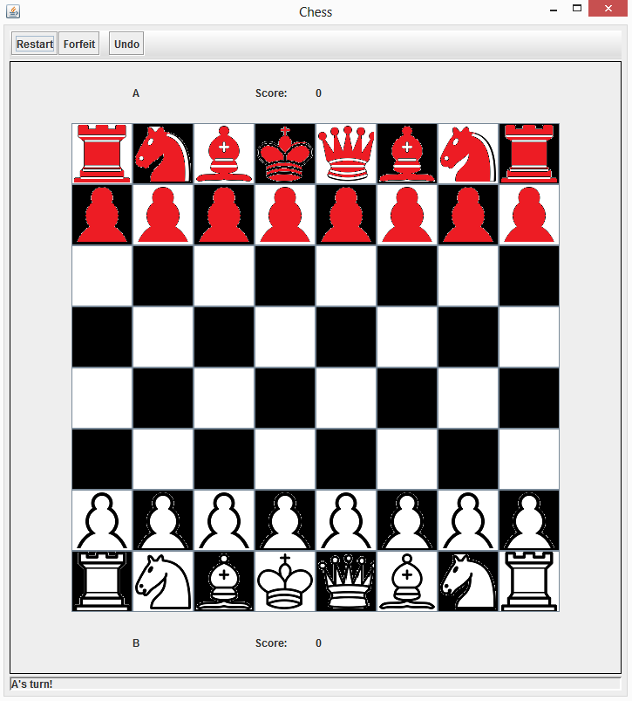Verify the correctness of the chess board appearance and colors for both modes. Click “Start” and then click which chess mode to play. Verify the chess piece locations. To try another mode, restart the game. See pictures below for correct configurations. Left is Classic Chess, right is Chuck Norris Chess.

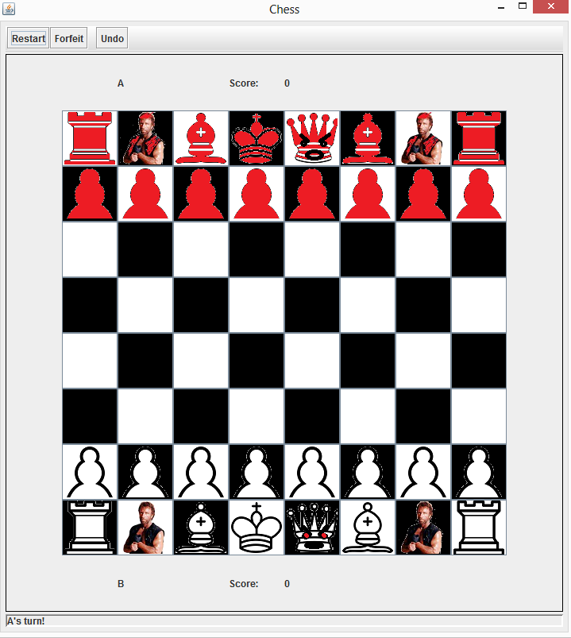

**Move / Capture Piece**

1. Click a piece of the corresponding player’s turn, it should highlight yellow.
2. Click a space to move that piece there.’
3. Click another piece of the same color, it should say “invalid move” on the bottom status bar.
4. Move a piece of the opposing color.
5. Repeat this alternating movement a few times, and capture a piece.

**Check/Checkmate**

1. Restart the game and play “Chuck Norris Chess”
2. Play against yourself, eliminate as many white pieces without eliminating any red pieces as you can. Put white into check by moving a piece within attacking distance of the king. Verify that the status bar below says you are in check if you try to make an invalid move.
3. Checkmate yourself. If you eliminate enough white pieces and have enough red pieces this should be trivial. Verify that a pop up appears, the score updates, and the board clears after checkmate.

**Forfeit**

1. Start a new game and forfeit on player 1’s turn, verify the score adjusts appropriately.
2. Start a new game and forfeit on player 2’s turn, verify the score adjusts appropriately.

**Undo**

1. The undo button should be greyed out.
2. Move a piece
3. The undo button should not be greyed out.
4. Click undo, and verify that the previous state is restored. Should be the previous player’s turn.
5. The undo button should be greyed out.